Abstract :
Networks of mobile drones are difficult to communicate with wirelessly since drones move from one position to another and are likely to experience frequent changes to network connectivity. The dependability of communication between drones and control stations is crucial in various scenarios like disaster management, surveillance, search and rescue, and remote monitoring. Traditional fixed network methods are not necessarily suitable for such fast-changing environments, as they rely on fixed communication routes and infrastructure. The proposed Wireless Drone Network Simulation is a wireless communication network simulation between 4 drones and a control station using Python. The system enables the data packets to be transferred by the intermediate drones from the source drone to the control station, in case of a non-available direct connection.
The proposed system takes into account the mobility of the drone and also the wireless transmission range to draw the conclusion of availability of communication links. The core ideas behind the networking implemented in the project is AODV (AD hoc On-Demand Distance Vector) routing – an on-demand routing that near the time required to discover communication paths. The AODV-style route discovery mechanism used in BFS as used in the simulation to find a path between the source and destination. The system also monitors the Packet Delivery Ratio (PDR), packet transmission loss, successful packet delivery and packet transmission to evaluate the network performance.
This simulation investigates the effect of wireless communication, topology changes, routing and mobility of nodes on the data transfer of a computer network composed by drone-based nodes, with emphasis on simplicity and practicality. It assists with developing the significance of effective routing in communicating with dynamic wireless networks.

Introduction :
Computer networking allows multiple devices to efficiently communicate with each other and exchange information. Wireless networking is particularly helpful when it is required that devices communicate without a fixed line connection, or where the fixed network infrastructure is unavailable. Drones, or Unmanned Aerial Vehicles (UAVs) are used in a variety of applications, including surveillance, disaster management, search and rescue, agriculture and remote area monitoring. With many drones operating together, they must be able to share data and coordinate between themselves and against a control station. Computer networking is thus essential to ensuring reliable communication between the drones. A drone's wireless connection and position may change throughout the broadcast.
This is a dynamic graph, with possible communication routes that could vary considerably. It is necessary to have a suitable routing mechanism to find and keep routes between source and destination. The Wireless Drone Network Simulation is a simulation of a wireless network comprised of four drones and a controller. Data packets are created by the source drone and intermediate forwarding nodes are other drones. The project follows an approach to access the available communication path according to the wireless connectivity information using AODV style on-demand routing method.
Some of the features included in the simulation are node mobility, packet transmission, packet loss and Packet Delivery Ratio (PDR). It offers hands-on experience on wireless communication, routing, node mobility and network performance in the mobile dynamic drone network.

Existing Systems :
Current drone communication systems utilize the wireless network technologies to help drones communicate with one another and with a ground station or controller. Depending on the application and amount of infrastructure available, various technologies can be adapted, including Wi-Fi, radio, cellular net and Mobile Ad Hoc Nets (MANETs). In multi-drone networks, data can be sent directly to the target drone, or it can be relayed by other drones (relay nodes) between the source and target drones. These systems are also important in relation to the role of routing protocols. Some of the protocols used to determine and keep communication path are AODV (Ad hoc On-Demand Distance Vector), DSR (Dynamic Source Routing) and OLSR (Optimized Link State Routing. For instance, in AODV, finding a route occurs only on demand, and is thus appropriate for networks that have a changing topology. When nodes are mobile, however, there are added challenges when implementing drone networks. During mobility, the distance between nodes changes, and new wireless links might form or break. This effectively makes it possible for an available route to be cut off, and another one to be found. Packet loss, routing problems, transmission delays and routing overhead can be experienced if a topology change happens too frequently. When the drones are far apart or flying in opposing directions, it is harder to keep them in touch.
One of the main drawbacks of the currently available real-world systems is that they are not easy to use for testing the various network scenarios. Physical and drone experiments have the following limitations: hardware, wireless equipment, battery power, enough space for operation, and safety measures. It can also be costly and time consuming to do experiments with various node positions and node motion patterns.
While there are routing protocols known to solve the issue of mobile communication, a simple and flexible one is required to be able to understand their behaviour in the changing network conditions. To meet this requirement, a software-based model is proposed for the Wireless Drone Network Simulation to permit to observe node movement, wireless connections, training of new routes, the transmission of wireless packets, and wireless packet loss without the need of physically flying drones. The previous system serves as baseline for wireless drone communication and constitutes the motivation for implementing wireless drone simulation system, which is simple, visual, controllable, and provides the platform for studying different drone dynamics and evaluating basic drone network performance.

Proposed / New System :
The Wireless Drone Network Simulation project is a Python based simulation system, which includes multiple mobile drones and a control station, designed to simulate wireless communication between the various mobile drones and between the mobile drones and the control station. The main aim of the system is to demonstrate how data can be transmitted through a dynamic wireless network when the positions of the drones change. The current network includes 5 nodes – 4 drones and 1 control station. DRONE-1 is a source to create data packets. DRONE-2, DRONE-3, and DRONE-4 are the intermediate nodes from where the packets are forwarded to the CONTROL-STATION which acts as the destination node. All the nodes are first inserted into a network area with a width and length of 500 meters. A wireless signal transmission distance of 150m is used to decide whether two nodes can communicate or not. Two nodes in this range are said to be wireless neighbours, and a communication link could be established. Links between the drones and the topology of the network are dynamic when drones move throughout the simulation.
The project adopts on-demand route discovery approach to route discovery, like AODV. DRONE-1 will send a packet to the CONTROL-STATION, the system will determine the set of nodes that are currently in its neighbouring nodes and look for a proper path. This process of finding out the route is considered as Breadth-First Search (BFS). If a node exists in the route, then the packet is successfully delivered, otherwise, the packet is lost. The proposed system also gives a graphical visualization of the network using Matplotlib. This visualization shows the position of drones, control station, wireless links between connected drones. This enables easy observation of changes in network topology and impact of drone motion on the communications. Finally, the System analyses the performance of the network based on the number of packets sent, number of packets received and lost packets. These values are then used to compute the Packet Delivery Ratio (PDR). It is useful in assessing the effectiveness of data delivered over the dynamic wireless network. So, the proposed system introduces ideas of wireless communication, mobile nodes, dynamic topology, AODV style routing, packet transmission to visualize and assess the performance into one simulation. Essentially, it offers an easy and affordable environment to learn and simulate communications in a wireless drone network without having to acquire physical drone devices.

Existing System vs Proposed System :

Existing System | Proposed / New System
Communication can be through a fixed infrastructure or already established communication routes. | Provides a wireless drone network based on a software solution for dynamically determining communication paths.
Studying connectivity may be a challenge when drones move. | Models’ mobility of drone and dynamically shifts wireless connectivity depending on nodes' positions.
Route maintenance can be affected by frequent topology changes. | Implements a route discovery method similar to AODV (as and when needed) to discover an available communication path.
To test real-world conditions, physical drones, wireless equipment and an environment must be provided. | Simulates network behaviors using Python, instead of physical drone hardware.
Changes in topology of a network during communication can be difficult to imagine. | Visualizes positions of drones and wireless links in simulation using Matplotlib plotting library.
More performance monitoring tools may be needed if you need to monitor the performance of your network. | Records packets sent, received and lost directly and calculates PDR.
It can be expensive and time consuming to evaluate the variation of network conditions. | Offers a controlled environment to change the position of the nodes, the transmission range and traffic condition.
Few opportunities to show the link between routing, mobility and delivery of the packet. | Integrates together node mobility, wireless connectivity, route discovery, packet transmission and assessment.

System / Network Architecture :
Architecture Diagram
Here's an interesting architecture diagram for your Wireless Drone Network Simulation: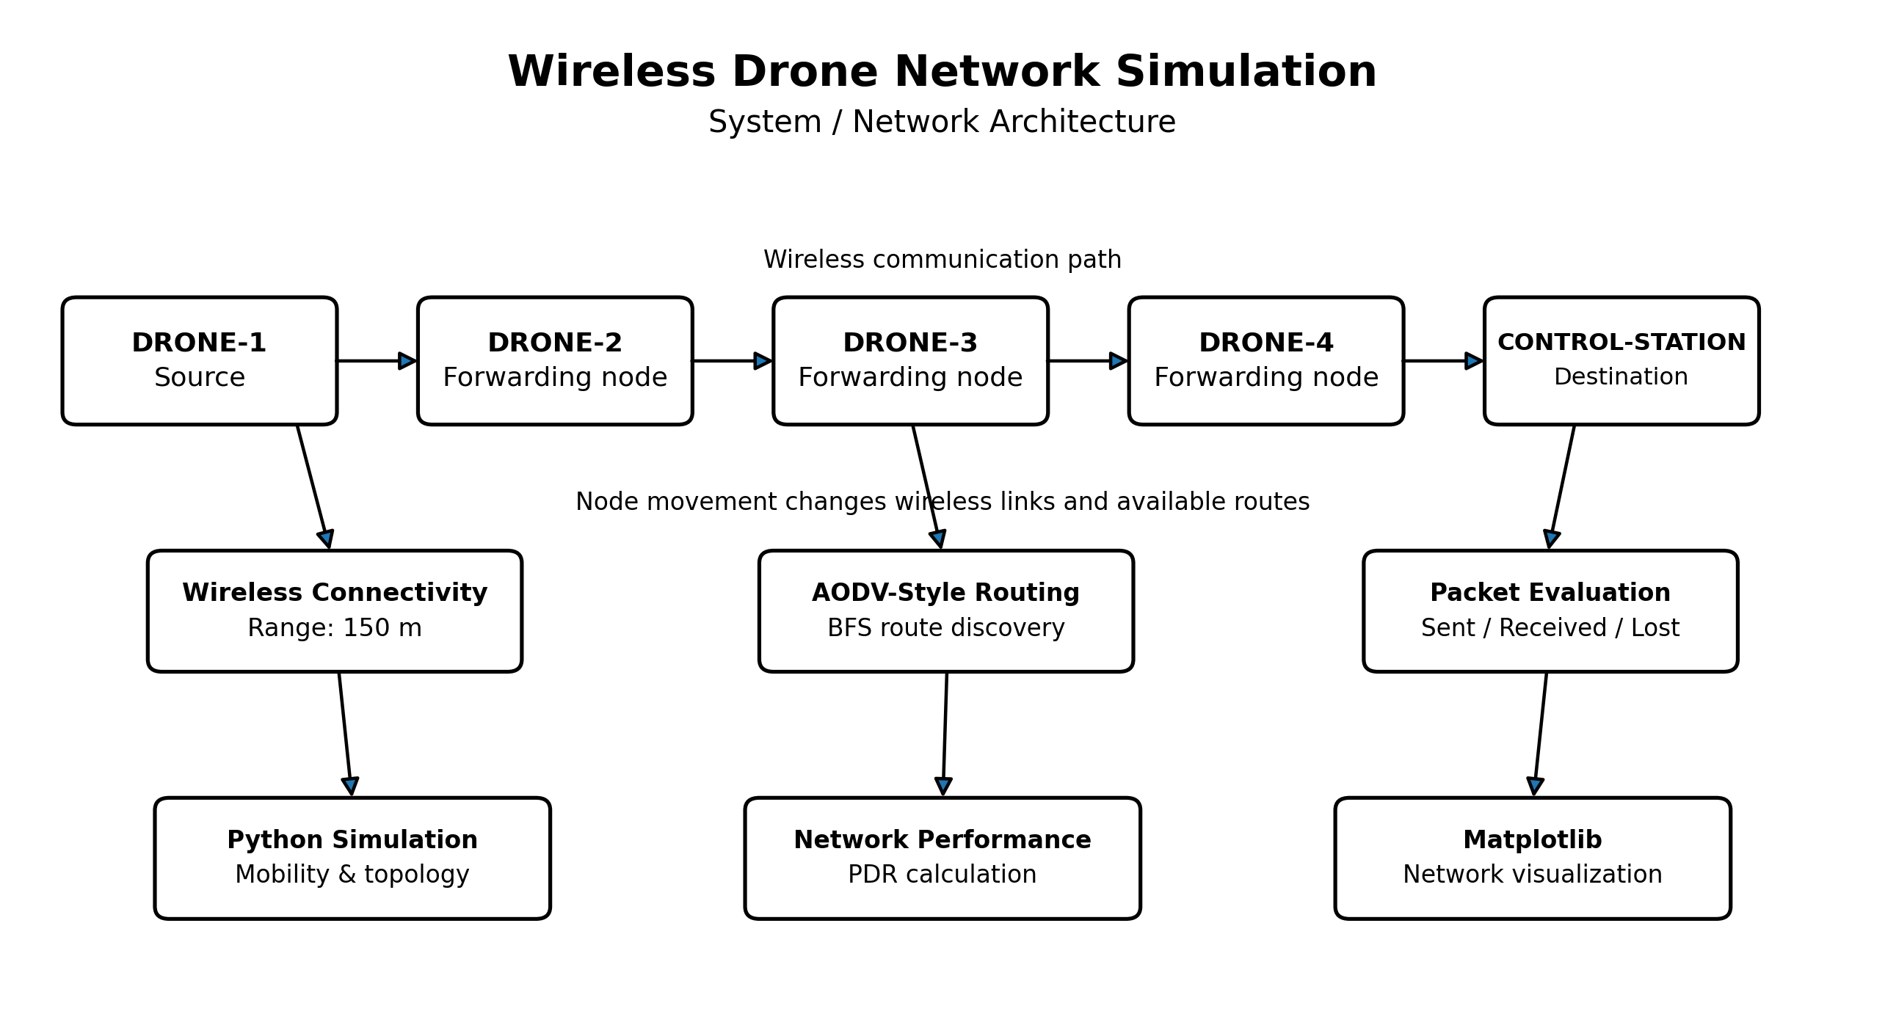
The total number of drones in the proposed system are 4 and the control station is 1. Communication flow begins from the source of DRONE-1 which works like DRONE-1 sensor generating data packets. The destination is the CONTROL-STATION and intermediate drones available are DRONE-2, DRONE-3, and DRONE-4 that are used to forward the packets toward the destination.
The wireless connection between nodes depends on their distance. Two nodes can be considered connected if they are close within 150 meters of each other. The wireless links available can vary, depending on the drones' movements, creating a dynamic topology.
The AODV-style routing module discovers routes on demand. In this simulation, BFS is employed to find a path from the source to target. If a route is available then the packet is said to be successfully delivered, else it is recorded as lost. The Python simulation and mobility model is used to move and place nodes, and the packet statistics module keeps track of the number of packets sent, received, and dropped. The values are used to calculate a Packet Delivery Ratio (PDR) which is used to assess network performance.

Communication Flow
DRONE-1 → DRONE-2 → DRONE-3 → DRONE-4 → CONTROL-STATION

Network Design and Implementation :
The design and implementation of networks. The Wireless Drone Network Simulation tackles the issue of small wireless ad hoc network, in which the mobile drones communicate with each other without the need to have any fixed network infrastructure. The implementation includes only concepts of networking that are being applied in the project.
Network Topology
The topology has dynamic wireless topology of 5 nodes:
DRONE-1 – Source node
DRONE-2 – Intermediate/forwarding node
DRONE-3 – Intermediate/forwarding node
DRONE-4 – Intermediate/forwarding node
CONTROL-STATION – Destination node
Initial positions of nodes are within a 500 x 500-meter space. The topology of the network can also be changed in the simulation as the drones can move about.
Wireless Connectivity
The wireless communication range of each node is 150 m. Two nodes are "neighbours" if the distance between the two nodes is within this range. The distance is calculated between the 2 nodes coordinates. So, for instance, communication links are formed when some drones are at a sufficient distance from others and disappear when they are too close for the communication to take place.
Routing Protocol
The project adopts an approach to routing that is similar to AODV. A route will only be searched when DRONE-1 must communicate with CONTROL-STATION. A Breadth First Search (BFS) is used to model route discovery. Algorithm looks at its neighbours and returns a path from the source node to target node. If a path exists, then the packet is considered successfully delivered; if not, then the packet is considered lost.
Packet Transmission
DRONE-1 repeatedly sends out packets every second of time from 1.0 to 4.5 seconds. The packets are defined to be 512 bytes in size each. The system keeps trying to find a route to the CONTROL-STATION in each iteration of the loop. The system keeps three important statistics:
Packets Sent
Packets Received
Packets Lost
These numbers are used to compute the Packet Delivery Ratio (PDR).
Node Mobility
The possibility to move nodes is added to take into account the dynamic nature of a drone network. Drones are moved to new coordinates at specific simulation times. This results in neighbouring changes of its nodes and may, as such, influence the availability of routes.
Network Performance
The most important performance measurement employed is the Packet Delivery Ratio (PDR). The Prorio Packet loss is calculated as follows:
PDR = (Number of Packets Received / Number of Packets Sent) × 100
Where:
Packets Received: This is the number of properly received packets at the Control Station.
Packets Sent = Number of ALL packets sent by DRONE-1.
A higher PDR means that more packets generated were able to arrive at the CONTROL-STATION.

Implementation Technologies
The network simulation is done in Python. Distance calculation is performed using the math module, BFS route discovery using deque, and visualization in Matplotlib for the network, node positions and wireless links.

Algorithm :
# ============================================================
# Wireless Drone Network Simulation
# Python Implementation
# ============================================================

import math
import time
import random
from collections import deque

import matplotlib.pyplot as plt

# ============================================================
# Simulation Parameters
# ============================================================

AREA_WIDTH = 500
AREA_HEIGHT = 500

NUMBER_OF_NODES = 5

# Wireless communication range
TRANSMISSION_RANGE = 150.0

# Packet configuration
PACKET_SIZE = 512
PACKET_INTERVAL = 0.05

# Traffic start and stop time
TRAFFIC_START = 1.0
TRAFFIC_STOP = 4.5

# Total simulation time
SIMULATION_TIME = 6.0

# Movement speed
MOVEMENT_SPEED = 10.0

# ============================================================
# Node Information
# ============================================================

nodes = [
{
"name": "DRONE-1",
"x": 50.0,
"y": 100.0,
"color": "red"
},

{
"name": "DRONE-2",
"x": 150.0,
"y": 200.0,
"color": "blue"
},

{
"name": "DRONE-3",
"x": 250.0,
"y": 100.0,
"color": "green"
},

{
"name": "DRONE-4",
"x": 350.0,
"y": 200.0,
"color": "yellow"
},

{
"name": "CONTROL-STATION",
"x": 450.0,
"y": 100.0,
"color": "magenta"
}
]

# ============================================================
# Movement Information
# ============================================================

movements = [
{
"node": 0,
"time": 0.5,
"x": 150.0,
"y": 200.0
},

{
"node": 1,
"time": 1.5,
"x": 250.0,
"y": 100.0
},

{
"node": 2,
"time": 2.5,
"x": 350.0,
"y": 200.0
},

{
"node": 3,
"time": 3.5,
"x": 450.0,
"y": 100.0
}
]

# ============================================================
# Packet Statistics
# ============================================================

packets_sent = 0
packets_received = 0
packets_lost = 0

# ============================================================
# Calculate Distance Between Two Nodes
# ============================================================

def distance(node1, node2):

dx = node1["x"] - node2["x"]
dy = node1["y"] - node2["y"]

return math.sqrt(dx * dx + dy * dy)

# ============================================================
# Find Wireless Neighbours
# ============================================================

def find_neighbors(node_index):

neighbors = []

for i in range(NUMBER_OF_NODES):

if i == node_index:
continue

d = distance(nodes[node_index], nodes[i])

if d <= TRANSMISSION_RANGE:
neighbors.append(i)

return neighbors

# ============================================================
# AODV-Style Route Discovery
# ============================================================

def find_route(source, destination):

"""
Finds a route from source to destination.

This uses a simple Breadth First Search (BFS)
to represent on-demand route discovery.
"""

queue = deque()

queue.append([source])

visited = set()

visited.add(source)

while queue:

path = queue.popleft()

current_node = path[-1]

# Destination reached
if current_node == destination:
return path

neighbors = find_neighbors(current_node)

for neighbor in neighbors:

if neighbor not in visited:

visited.add(neighbor)

new_path = path + [neighbor]

queue.append(new_path)

# No route available
return None

# ============================================================
# Move Drones
# ============================================================

def update_movement(current_time):

for movement in movements:

node_id = movement["node"]

movement_time = movement["time"]

if current_time >= movement_time:

nodes[node_id]["x"] = movement["x"]
nodes[node_id]["y"] = movement["y"]

# ============================================================
# Send Packet
# ============================================================

def send_packet():

global packets_sent
global packets_received
global packets_lost

source = 0
destination = 4

packets_sent += 1

# Discover route using AODV-style routing
route = find_route(source, destination)

if route is not None:

# Packet successfully reaches destination
packets_received += 1

print(
f"Packet {packets_sent}: "
f"DRONE-1 -> CONTROL-STATION "
f"Route: {route}"
)

else:

# No route available
packets_lost += 1

print(
f"Packet {packets_sent}: "
f"Route unavailable - Packet Lost"
)

# ============================================================
# Display Network
# ============================================================

def draw_network():

plt.clf()

# Draw wireless links
for i in range(NUMBER_OF_NODES):

for j in range(i + 1, NUMBER_OF_NODES):

d = distance(nodes[i], nodes[j])

if d <= TRANSMISSION_RANGE:

x_values = [
nodes[i]["x"],
nodes[j]["x"]
]

y_values = [
nodes[i]["y"],
nodes[j]["y"]
]

plt.plot(
x_values,
y_values,
linestyle="--",
linewidth=1
)

# Draw nodes
for i, node in enumerate(nodes):

plt.scatter(
node["x"],
node["y"],
s=300,
color=node["color"],
edgecolors="black"
)

plt.text(
node["x"],
node["y"] + 15,
node["name"],
ha="center",
fontsize=9,
fontweight="bold"
)

plt.xlim(0, AREA_WIDTH)
plt.ylim(0, AREA_HEIGHT)

plt.xlabel("X Position (meters)")
plt.ylabel("Y Position (meters)")

plt.title("Wireless Drone Network Simulation")

plt.grid(True)

plt.pause(0.01)

# ============================================================
# Main Simulation
# ============================================================

def run_simulation():

global packets_sent
global packets_received
global packets_lost

print()
print("=" * 50)
print(" WIRELESS DRONE NETWORK SIMULATION")
print("=" * 50)
print()

print("Network Area : 500 x 500 meters")
print("Number of Nodes : 5")
print("Routing Protocol : AODV-style routing")
print("Packet Size :", PACKET_SIZE, "bytes")
print("Packet Interval :", PACKET_INTERVAL, "seconds")
print("Traffic Start :", TRAFFIC_START, "seconds")
print("Traffic Stop :", TRAFFIC_STOP, "seconds")
print()

plt.figure(figsize=(9, 7))

current_time = 0.0

next_packet_time = TRAFFIC_START

movement_index = 0

while current_time <= SIMULATION_TIME:

# ----------------------------------------------------
# Update drone positions
# ----------------------------------------------------

update_movement(current_time)

# ----------------------------------------------------
# Generate packets
# ----------------------------------------------------

if (
current_time >= TRAFFIC_START
and current_time < TRAFFIC_STOP
and current_time >= next_packet_time
):

send_packet()

next_packet_time += PACKET_INTERVAL

# ----------------------------------------------------
# Update visualization
# ----------------------------------------------------

draw_network()

# Display simulation time
plt.text(
10,
470,
f"Simulation Time: {current_time:.2f} s",
fontsize=11
)

# Move simulation forward
current_time += 0.05

time.sleep(0.02)

# ========================================================
# Calculate Packet Delivery Ratio
# ========================================================

if packets_sent > 0:

pdr = (
packets_received /
packets_sent
) * 100

else:

pdr = 0

# ========================================================
# Display Final Results
# ========================================================

print()
print("=" * 50)
print(" NETWORK PERFORMANCE RESULTS")
print("=" * 50)

print(
f"Packets Sent : {packets_sent}"
)

print(
f"Packets Received : {packets_received}"
)

print(
f"Packets Lost : {packets_lost}"
)

print(
f"Packet Delivery Ratio : {pdr:.2f}%"
)

print("=" * 50)

plt.show()

# ============================================================
# Start Simulation
# ============================================================

if __name__ == "__main__":

run_simulation()

Expected Outcome :

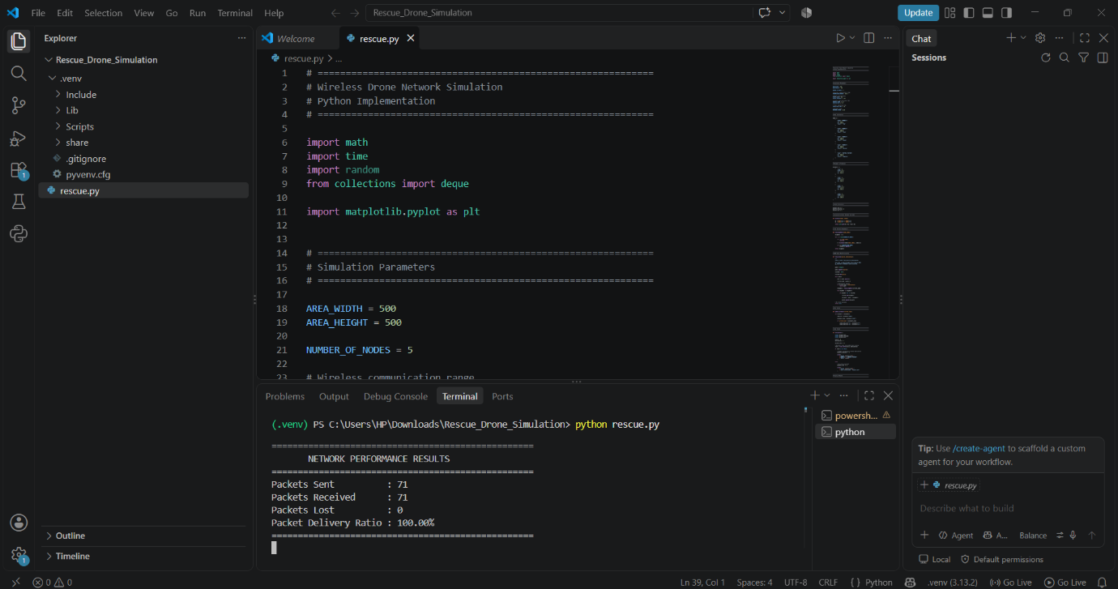

==================================================
WIRELESS DRONE NETWORK SIMULATION
==================================================
Network Area : 500 x 500 meters
Number of Nodes : 5
Routing Protocol : AODV-style routing
Packet Size : 512 bytes
Packet Interval : 0.05 seconds
Traffic Start : 1.0 seconds

==================================================
NETWORK PERFORMANCE RESULTS
==================================================
Packets Sent : 71
Packets Received : 71
Packets Lost : 0
Packet Delivery Ratio : 100.00%
==================================================
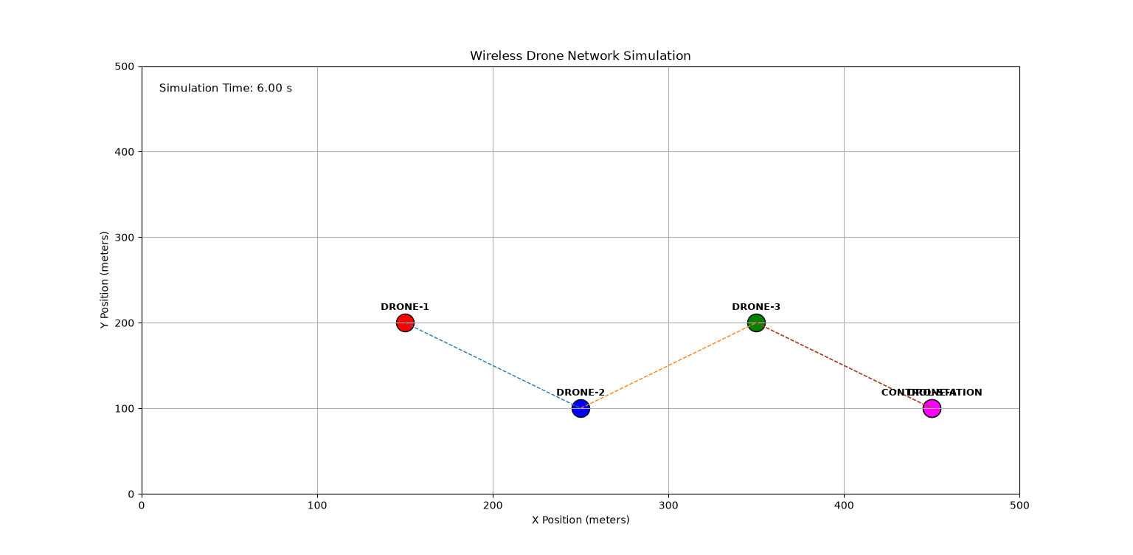
The Wireless Drone Network Simulation is expected to show the behaviour and performance of a small mobile wireless network when the nodes move. These are the measurable outcomes that can be achieved with the simulation:
- Dynamic Network Topology: All drones' links between each other are changing as the nodes move in the 500 m x 500 m region of the simulation.
- Route Discovery: When there is a valid route from source (DRONE-1) to destination (CONTROL-STATION) route is discovered with BFS mechanism similar to AODV. The simulation information consists of the number of packets sent, successfully received and lost during the communication procedure.
- Packet Delivery Ratio (PDR): it's determined by taking the number of packets received successfully and dividing it by the number of packets sent:
Packets Sent = the number of packets sent by the sender.
- Effect of Mobility: Node movement explores how the wireless connections that are established and maintained depend on changes in drone positions and what impact that has on packet delivery.
- Network Visualization: They simulate the update of the drone positions, their links, and visualize them using Matplotlib.
- Performance Evaluation: Packet statistics and PDR are measured parameters that can be used for performance evaluation of the drone network being simulated.

Advantages :
Some main benefits of the Wireless Drone Network Simulation are:
- Low-Cost Simulation – The network does not require physical drones and wireless equipment, and the network can be tested at the same time in Python.
- Easy Visualization – Matplotlib offers visualizations of drones, wireless links, and node moves.
- Dynamic Network Analysis – simulate the changes to wireless network topology when nodes move.
- Route Discovery – The AODV routing style of BFS can discover a route from the source drone to the control station.
- Packet Performance Measurement – The system keeps count of “packets” sent, received and lost.
- Packet Delivery Ratio (PDR) calculation – PDR is a measurable metric to assess successful packet delivery.
- Flexible Parameters – All the Areas, Range of Transmission, Packet interval, Simulation time and Position of the nodes can be changed easily.
- Helpful to learning – The simulation allows students to learn about key networking concepts like loss, wireless networking, network mobility, lossless, and performance. Easy to modify and extend – add more drones, mobility pattern, routing technique or performance.
- Safe Testing Environment – Test different network conditions without risk and practical difficulties of testing real drones.

Limitations :
The main drawbacks of Wireless Drone Network Simulation are:
- If the Project is not implemented in real drones, real wireless communication equipment, and throws a virtual drone onto the computer, it is the Simulation-Based System.
- Adapted AODV with Angular Tree – The use of Adapted AODV with Angular Tree is simulated by the implementation using BFS. It does not support all of the AODV protocol such as RREQ, RREP, and RERR (return error) messages.
- Fixed Mobility Pattern – Drone mobility pattern is fixed for the time of the simulation in place of real flight behaviour.
- Simplified Wireless Model – Communicating is largely determined by the fixed 150 m transmission distance. Interference, obstacles, fading, and signal strength which are factors in the real world are not being modelled.
- Small Drones and Small Artificial Sun – The simulation has 4 drones, and a single control station; so, the simulation is not intended to simulate the behaviour of a large-scale drone network.
Current implementation only measures packets sent, received, lost and Packets Delivered Ratio (PDR).
The following metrics are not computed: end-to-end delay, throughput, routing overhead, energy consumption.
- No Real Network Communication – No actual IP-addresses, TCP/UDP sockets or communication between real devices used.
- Simplified Packet Model – The packets in the simulation are not actually sent as 512-byte network packets, but are represented logically in the simulation.
- There is no Energy Model – Drones are not considered to have energy limitations and consumption.
- Limited Real-World Validation – Results are generated in a controlled simulation and may vary from true performance in a real, operating, drone network, in real environmental conditions.

Applications :
The Wireless Drone Network Simulation can be used in the following applications:
- Disaster Management – Drones can be used to gather and relay information from flood, earthquake or other disaster impacted areas.
- Search and Rescue Operations – Multiple drones can be used to search for a large, difficult-to-access area and return information to a control station.
- Surveillance and Security – Through the use of information sharing between the drone and the central control station, a network of drones can provide the CSE with added coverage for a large area.
- Agricultural Monitoring – Drones can monitor the agricultural area, dryness of farmland, irrigation and others depending on the agricultural parameters.
- Remote Area Monitoring – Communications and collecting data in remote areas without fixed communications is possible by using drone networks.

Future Scope :
The Wireless Drone Network Simulation could be enhanced and extended by the following: Extension of the simulation to implement actual AODV mechanisms like RREQ, RREP, and RERR messages.
- Complete AODV Implementation – The actual AODV mechanisms like RREQ, RREP, and RERR can be implemented.
- Realistic Drone Mobility – real-world flight patterns and random mobility, speed variations and avoidance of obstacles can be added in.
- Larger Drone Networks – More drones can be added to examine performance of larger and more complex networks.
- Additional Performance Metrics – It is allowed to add other performance metrics like throughput, end to end delay, overhead in the routing and the energy consumption etc.
- Real-Time Communication – The simulation can be linked to real-time devices or drone hardware, using wireless communication technology.
- Better Wireless Model – Interference, signal strength, signal obstacles, propagation loss, environment etc. can be included.
- Energy-Aware Routing – Using Battery Level of Drones as a selection criteria to result in a longer network lifetime.
- Advanced Routing Algorithms – Other routing algorithms can be implemented and compared to the AODV-style approach to find better routing performance.
- Integration with Real Drone Systems – Integration with Real Drone Systems or drone simulators in the future for more realistic tests.
- AI-Based Routing – Machine learning or (AI) algorithms can be used to forecast network conditions and determine optimal communication paths.

Conclusion :
Wireless Drone Network Simulation is used to show the ability of a wireless network between a group of mobile drones and control station. The project models the different nodes that include 4 drones and one control station at a design space of 500 × 500 m using a Python script. Routes are discovered as the drone positions change using an approach similar to AODV with a BFS routine for finding the routes.
The upcoming simulation also shows the impact of packet transmission when the nodes move around and the wireless connection links change. Sending, receiving, and dropping of packets are tracked and the packet delivery ratio (PDR) calculated to measure network performance. The network and its evolution of topology can be visualized using Matplotlib.
Overall, the project gives the simple and cheap understanding of both fundamental concepts like wireless communication and routing and some other concepts like mobility, packet loss, and testing the performance of the network. It provides also a baseline for future extensions like full AODV parameterization, more realistic mobility scenarios, adding other metrics or increasing drone populations.

References :
Ad Hoc On-Demand Distance Vector (AODV) Routing, RFC 3561, Internet Engineering Task Force (IETF), 2003.
Ad-hoc On-Demand Distance Vector Routing by C. E. Perkins and E. M. Royer, Proceedings of the 2nd IEEE Workshop on Mobile Computing Systems and Applications (WMCSA), 1999. Introduction to Algorithms, 3rd Edition by T. H. Cormen, C. E. Leiserson, R. L. Rivest, and C. Stein, MIT Press, 2009. (As an example, for Breadth-First Search (BFS).)
The Python Software Foundation is responsible for the documentation of Python.
Python world of programming concepts and references to standard libraries.
Matplotlib Documentation. Matplotlib Documentation is written by the Matplotlib Development Team.
(For the visualization and graphical plotting of networks.)
Ad Hoc Networking, C. E. Perkins, Addison-Wesley, 2001.
(Reference pour les concepts des réseaux ad hoc pour applications mobiles et de routage sans fil.).

GitHub Repository :
The complete Python source code and implementation of the Wireless Drone Network Simulation project are available on GitHub.
Repository Link: https://github.com/poojahk38-collab/Wireless-Drone-Network-Simulation

